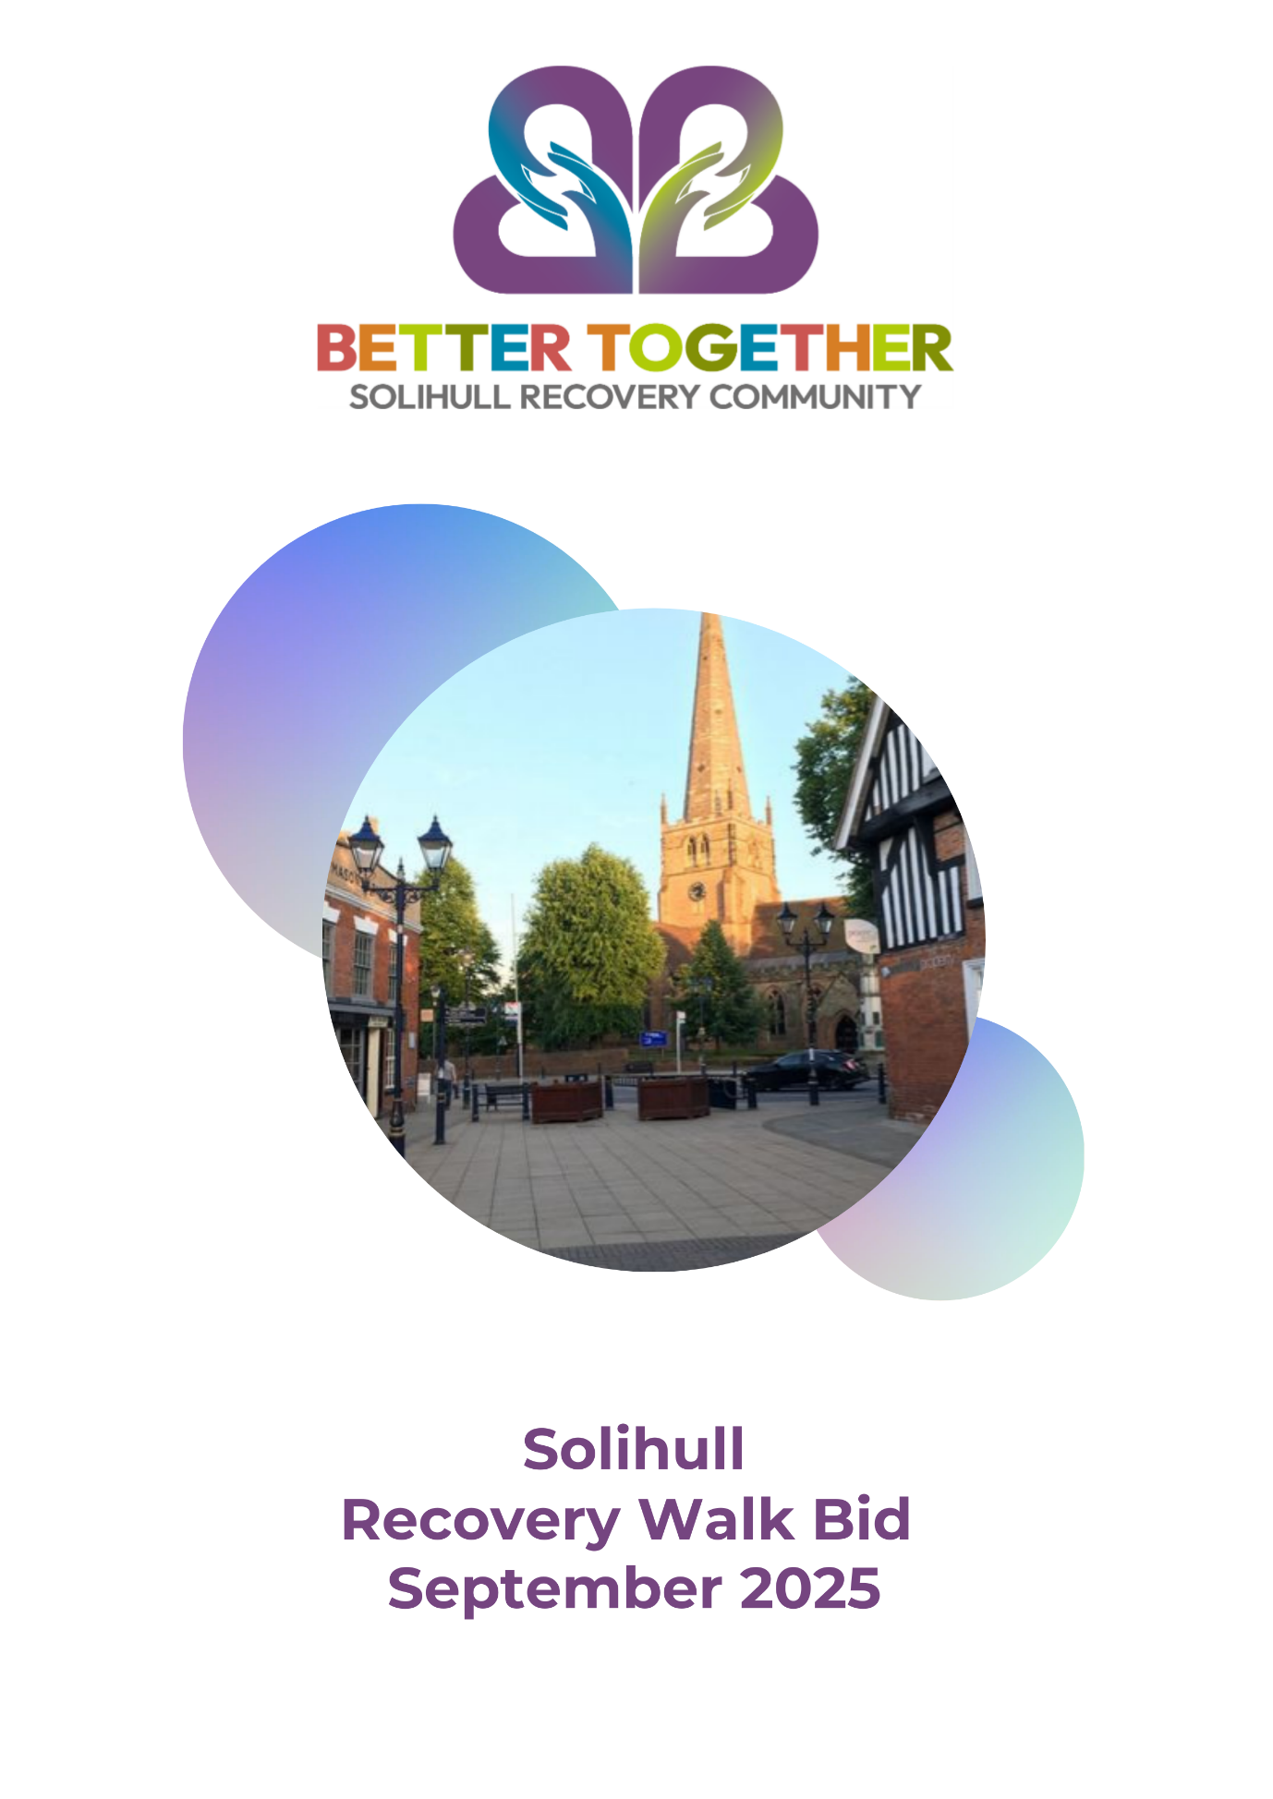

**Table of Contents**

**Summary 3**

**Supporting Statements 4 - 5**

**Solihull 6 - 7**

**Recovery in Solihull 8 - 9**

**Proposal for Recovery Walk 10 - 12**

**Partners 13 - 14**

**Getting to Solihull 15**

**Access to Malvern and Brueton Parks 15**

**Choice of Venues 16 - 17**

**Finances 18**

**Summary**

Newly-formed Lived Experience Recovery Organisation (LERO) Better Together – Solihull Recovery Community is leading this bid to host the national Recovery Walk 2025 in Solihull, supported by stakeholder, partners and champions working in Solihull, including Solihull Integrated Addiction Service (SIAS), Solihull Council, Solihull Bid and Anchor.

We believe that Solihull offers an ideal location in the heart of England - therefore easy to reach, with excellent conference facilities and two linked adjoining parks very close to the town centre. This means we can accommodate the conference in a high-quality setting and that the Recovery Walk can take a flat and picturesque circular route through the parks, past the ancient church of St Alphege and into the heart of the outdoor shopping area to help make recovery visible. Solihull town centre regularly hosts street events, so shoppers are used to engaging with stalls and activities along the High Street and in Mell Square.

**Supporting Statements**

***Dr Ed. Day- National Recovery Champion***

The concept of a recovery walk through a town or city centre has become a crucial part of a local Recovery Orientated System of Care (ROSC). The day of the walk is a celebration of recovery from addiction, a coming together of people that have overcome adversity and are now living a life that they never thought was possible. It is often said that the opposite of addiction is connection, and there is no better way of doing this by a large and visible gathering. The walk challenges the stigma of addiction, demonstrating the power and vitality of communities of recovery. Walking proudly through the centre of a town demonstrates what recovery can bring to an individual, their family and the wider community.

The metropolitan borough of Solihull has commissioned a Lived Experience Recovery Organisation (LERO) for over 15 years as part of an integrated addiction treatment service (SIAS). SIAS recognises the power of lived experience and the benefits that it can bring to a ROSC. Better Together staff provide visible hope that recovery is possible while linking clients of the service to positive assets in their local community. Meaningful activity, connection with others and practical tools to build recovery capital all complement the treatment process. Hosting the national Recovery Walk in Solihull would be a great way to celebrate this work.

**Dr Ed Day (*he/him*)**

**Clinical Reader in Addiction Psychiatry**

***Ruth Tennant- Director of Public Health Solihull***

Hosting the Recovery Walk 2025 in Solihull Town Centre will mark a significant milestone in our ongoing commitment to raising awareness, fostering hope, and supporting those on the journey to recovery from addiction.

Recovery is a powerful testament to human resilience, and this walk stands as a symbol of strength, unity, and the collective effort it takes to overcome the challenges of addiction.

***Cllr Tony Dicicco - Cabinet Portfolio Holder - Adult Social Care and Health***

We aim to come together in Solihull, to celebrate not only the individuals who have fought tirelessly to reclaim their lives but also the communities, families, and professionals who have stood by their side, offering encouragement and support.

The walk will bring together people from all walks of life—those in recovery, their families, healthcare providers, local organisations, and supporters of all kinds. The route will lead through the heart of Solihull, symbolising the journey from addiction to recovery and transformation. Along the way, we will share stories, offer encouragement, and raise our voices to reduce the stigma surrounding addiction, while promoting the message that recovery is always possible.

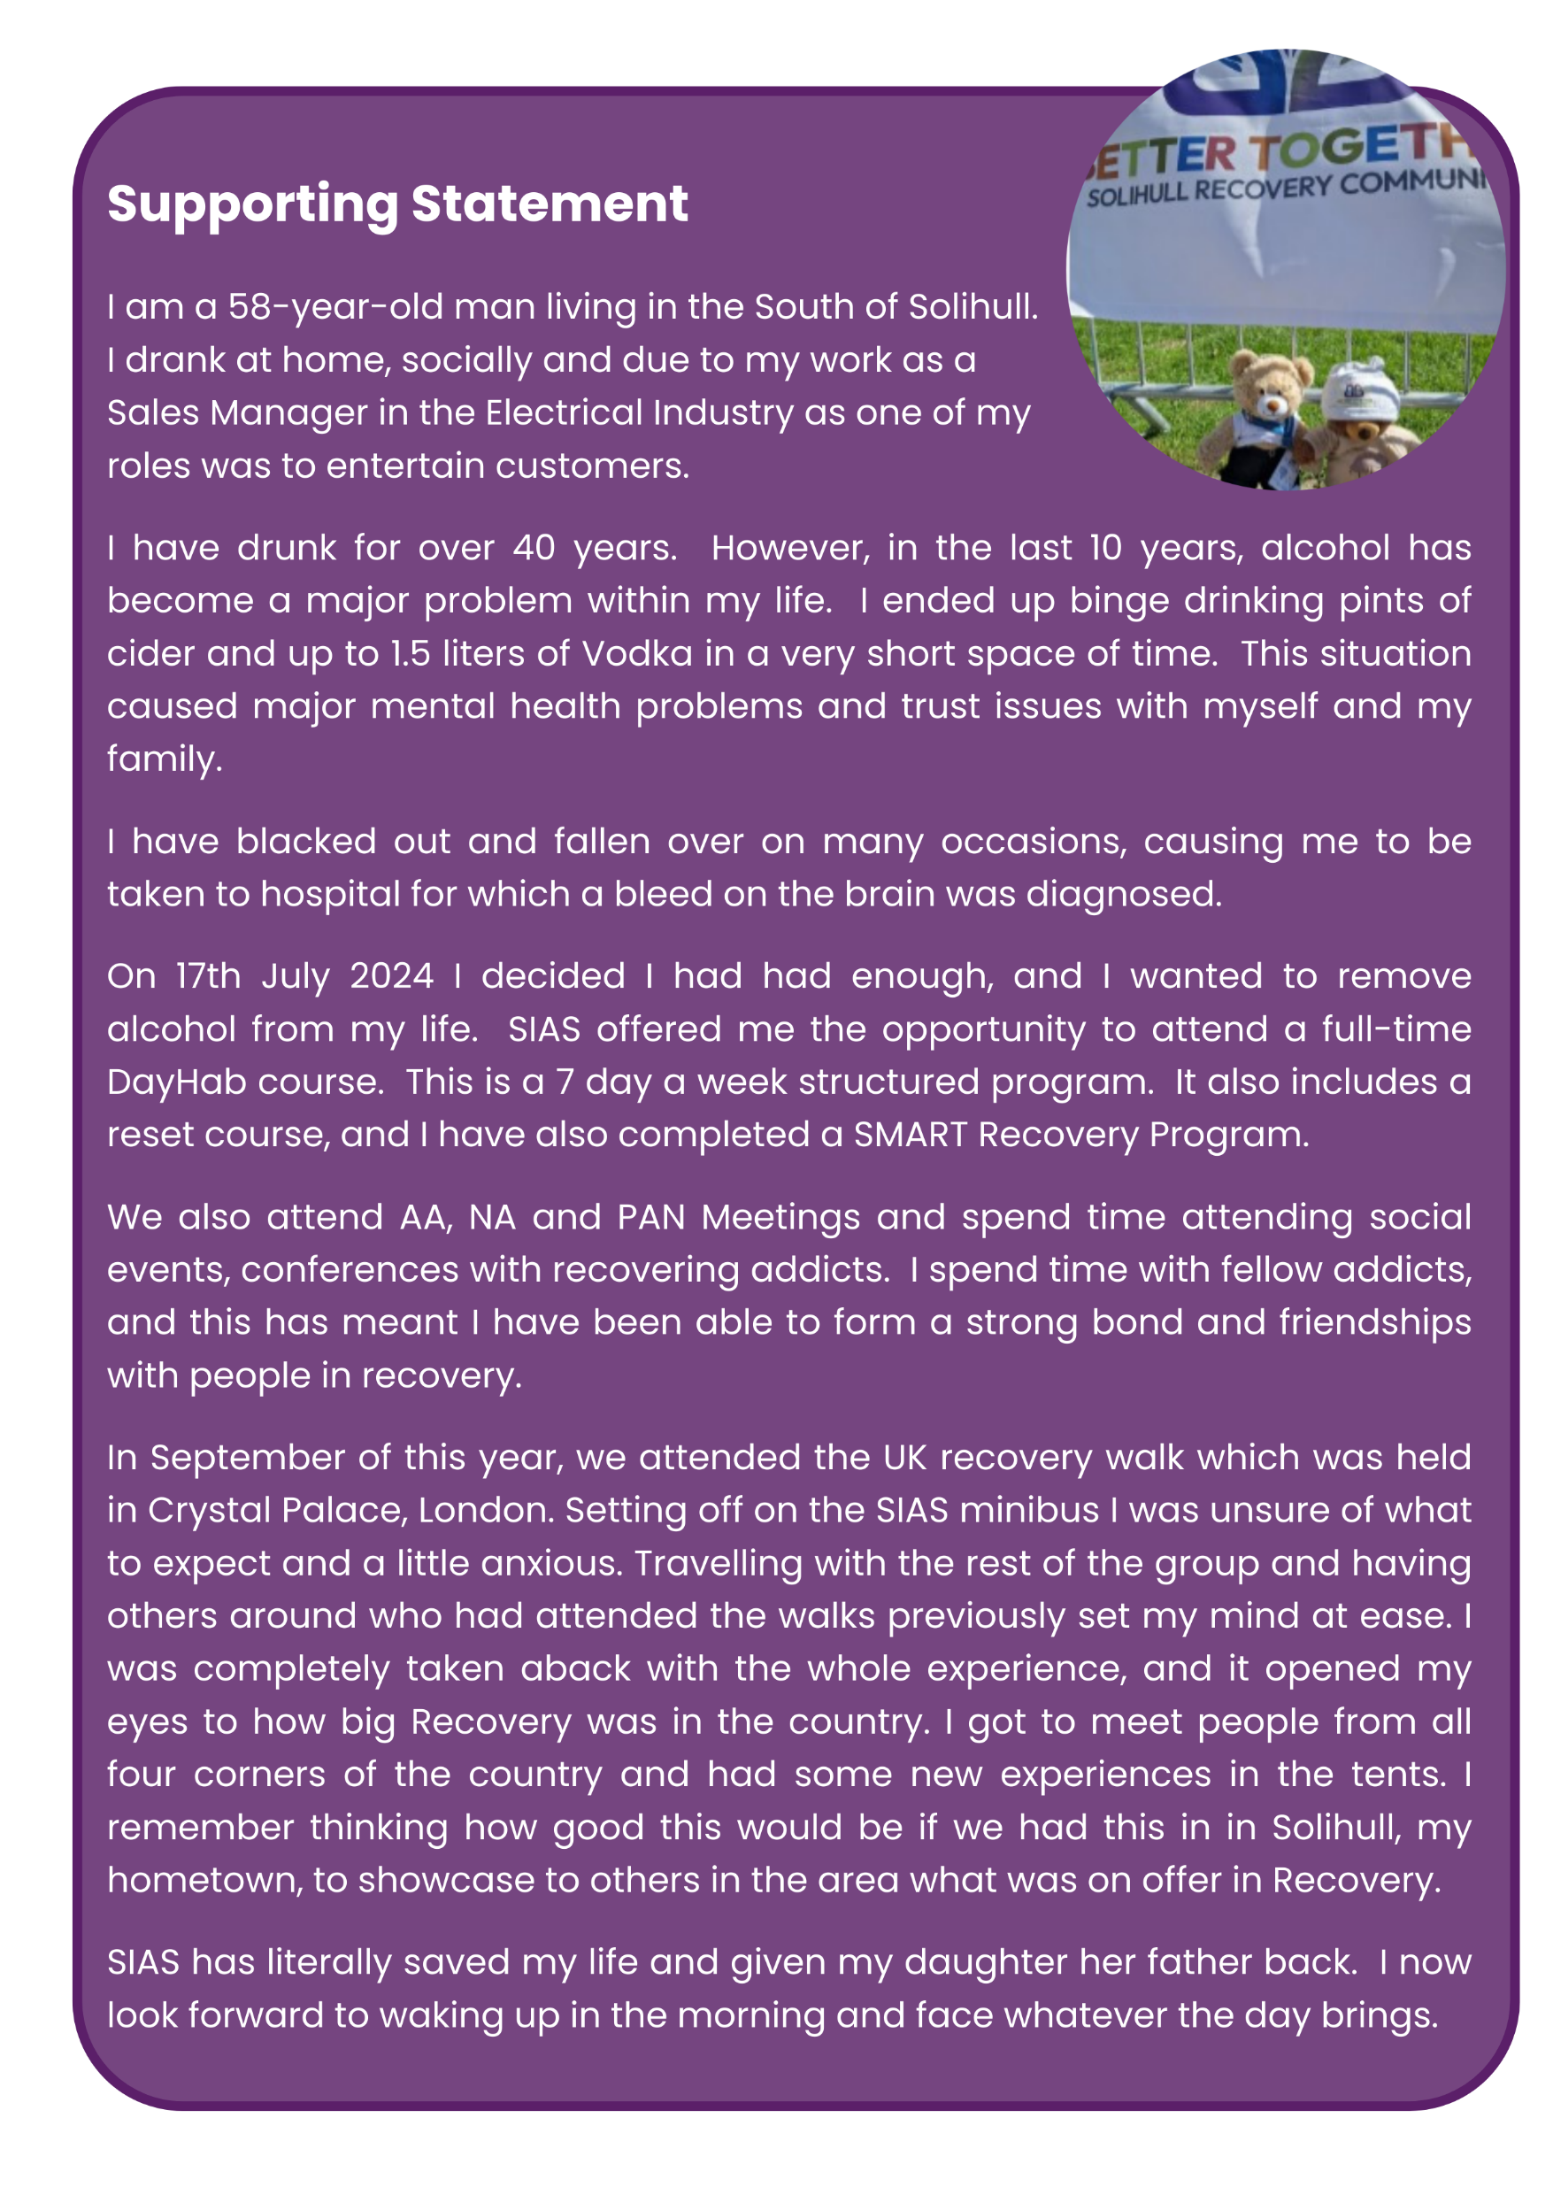

**Solihull**

Solihull is a market town located 8 miles (12 km) southeast of Birmingham and 13 miles (21 km) west of Coventry in the county of the West Midlands. It is the administrative centre of the Metropolitan Borough of Solihull.

Solihull itself is mostly urban; however, the larger Borough is rural in character, with many outlying villages. Situated on the River Blythe in the historic Forest of Arden area, three quarters of the Borough is designated as green belt land.  The town had a population of 126,577 at the 2021 Census, and its wider Borough had a population of 216,240.

The town and its Borough, which has been part of Warwickshire for most of its history, has roots dating back to the 1st century BC and was further formally established during the medieval era. Today the town is famed as, amongst other things, the birthplace of the Land Rover car marque, home of the training facilities for the British equestrian teams and is considered to be one of the most prosperous areas in the UK.

Solihull's name is commonly thought to have derived from the position of its medieval Grade 1 listed Arden stone parish church, St Alphege, on a 'soily' hill.  The church was built on a hill of stiff red marl, which turned to sticky mud in wet weather.

Despite its proximity to cities like Birmingham to the northwest, Coventry to the east, Worcester to the southwest and the build-up of conurbations around nearby Warwick, Stratford upon Avon, the Royal Town of Sutton Coldfield, and Royal Leamington Spa, Solihull maintains its unique and distinct identity and is bordered by greenbelt countryside to the south and east.

High Street, Solihull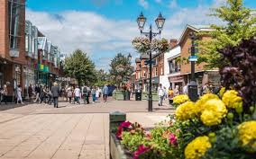

Mell Square, Solihull 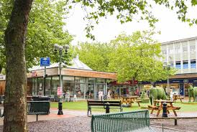

Conveniently situated in the centre of England, with easy access from the motorway network

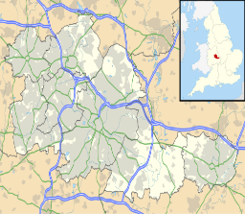

***The Centre of England***

|  |  |
| --- | --- |
|  | The village of Meriden in the Borough of Solihull was historically regarded as the centre of England and marked the dividing line between England’s north and south. A listed stone monument commemorating Meriden's status as 'Centre of England' sits on the village green. |

***Malvern and Brueton Parks***

Two parks in one, Malvern and Brueton Parks, are perfectly located near Solihull town centre. With [**Green Flag Park**](https://www.greenflagaward.org/)   
status, the space offers visitors and locals an easily   
accessible space to relax and play.

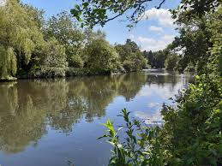

Facilities include:

* a modern playground
* a dedicated picnic spot
* Brueton Tree Trail
* free car parking
* local nature reserve
* mature woodland
* ornamental gardens
* ornamental lake

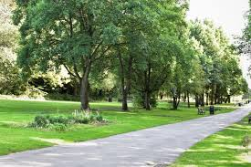

* park events
* Parkridge Cafe
* pond
* sensory garden
* tennis courts
* walking trails

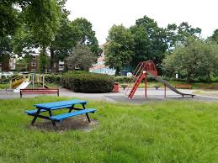

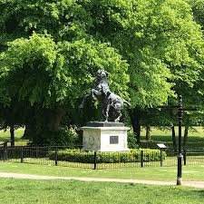

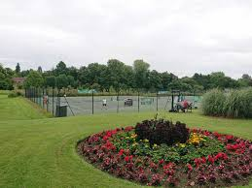

**Recovery in Solihull**

Solihull Metropolitan Borough Council, commissions drug & alcohol treatment & recovery services in Solihull through the SIAS (Solihull Integrated Addiction Services) Partnership.



SIAS partners work seamlessly together to offer a range of free services including:

* Treatment - for adults and young people
* Support for adults in recovery from addiction
* Needle Exchange and harm reduction service
* Support with housing and homelessness
* Support for families, including children, affected by someone else’s substance misuse
* Drug and alcohol awareness training – for professionals
* Drug and alcohol awareness workshops for schools, colleges, and businesses
* Signposting for people with a gambling addiction

***Better Together - Solihull Recovery Community***

SIAS Partner Better Together - Solihull Recovery Community, rose from the ashes of its predecessor in 2024, with support from other SIAS Partners, collaboration with the national College of Lived Experience Recovery Organisations (CLERO) and guidance from the National Recovery Champion, Dr Ed Day.

Better Together – Solihull Recovery Community is a Lived Experience Recovery Organisation (LERO) dedicated to transforming lives through the power of lived experience and visible recovery in the community. It is founded and driven by individuals who have navigated their own recovery journeys and now offer unique insights and empathetic support to others.

Within the SIAS Partnership, it offers a variety of services which ‘wrap around’ the treatment provision and are designed to support individuals at all stages of their recovery journey, including:

* Peer support from trained peers who have lived through similar experiences,
* Daily drop in Hub
* DayHab Wellness Programme
* Workshops & training
* Educational programs aimed at skill-building and enhancing recovery knowledge
* Community events and social activities, including walking and cycling events that promote connection and reduce isolation

Support is offered from 9am – 9 pm, 7 days a week. Better Together – Solihull Recovery Community also links with local assets such as mutual aid, community groups and local businesses to further support service users in acquiring sustainable recovery capital.

**Proposal for Recovery Walk 2025**

**Friday 12th September**

**FAVOR Conference 10am to 4pm**

**Memorial Service 6pm to 9pm**

**Sleepover - overnight**

**Saturday 13th September**

**Recovery Walk 11am to 1pm**

***FAVOR Conference***

There is a variety of venues to choose from for the FAVOR Recovery Conference on the Friday night, including external venues such as the local St John’s Hotel, Solihull College Conference Centre or Council buildings including, The Core Theatre, or a range of Family Hubs settings that can facilitate conference numbers, all of which are very close to the town centre with accessible transport links.

Working within the SIAS Partnership, we have the National Recovery Champion Dr Ed Day, who would be available to work alongside FAVOR in ensuring the Recovery Conference will be one to remember, continuing to set itself apart as the premium recovery conference within the calendar year.

***Memorial Service & Friday Night Sleepover***

We are committed to continuing the tradition of hosting both a Friday Memorial Service and Friday Night Sleepover at the 2025 Recovery Walk and have access to the hall at The Bridge in Shirley on offer to those wishing to connect and build up a network of recovery buddies. The Bridge will offer a Service of Memorial within its church hall to offer out to those seeking a place to remember those of us who did not make it through addiction.

***Recovery Walk***

The proposed walk will take place on Saturday 13th September 2025, with Malvern Park being the start and finish point. The walk will exit Malvern Park and take in the top of Solihull High Street, across George Road to Mell Square and take the same route back (1.2km) where it will enter Malvern Park into the Recovery Village.

Solihull as an area as a wide variety of both open and closed spaces within its borough, in order for us to showcase and reach the wider community we have the option of utilising other venues within Solihull, bringing in the Town centre, local colleges and hotels.

***Aspirations, Vision and Lasting Legacy***

***Our Vision: Empowering a Recovery Community in Solihull***

We are committed to building a compassionate, inclusive community that champions recovery and promotes wellbeing. Hosting the UK Recovery Walk 2025 would provide us with a unique opportunity to raise the profile of addiction and wellbeing services within the area, while bringing together service users, families, and organisations to celebrate the achievements of those in recovery.

The logistics of Solihull make for strange bedfellows, from the leafy affluent areas spread across the south of the borough to the more urban deprived areas of the north. We currently have twelve mutual aid meetings across the borough, mostly situated central to both town centres within the borough. The local recovery community has an abundance of people from both sides, although again, those in attendance are housed within walking distance from both town centres. We believe the opportunity of hosting a ‘National Recovery Event’ will give us the opportunity of reaching into the hard-to-reach areas, making recovery visible, attainable and cool.

Through the collective effort of the SIAS Partnership, we support people in their journey of recovery with a wide range of programmes and groups tailored to meet varied needs. These include talking groups, mindful reading sessions, SMART Recovery, a RESET Programme, and dedicated spaces for men’s and women’s support. Many SIAS staff members have lived experience with alcohol or substance use, enabling them to build empathetic, authentic relationships with those they support, fostering a culture of mutual trust, understanding, and encouragement. Our aim is for everyone who engages with us to feel understood, supported, and celebrated for their progress.

**Building Lasting Impact in Solihull and Beyond**

By hosting the UK Recovery Walk 2025, we aspire to establish a long-lasting legacy that reinforces the principles of recovery and community empowerment.

1. **Solihull as a National Champion of Recovery:** Solihull will stand as a beacon of recovery, setting an example for communities nationwide. The Walk will elevate Solihull’s profile, aligning with other UK cities in championing recovery and showing that addiction recovery is not just possible but thriving. Through this event, we’ll cultivate a reputation as a community where recovery is seen, valued, and celebrated.
2. **Growing and Strengthening the Recovery Network:** The Walk will serve as a catalyst for ongoing collaboration, fostering partnerships among organisations, individuals, and support networks across Solihull and the wider West Midlands. This event is only the beginning; we are dedicated to building and growing our recovery network and creating new partnerships that bridge gaps, improve resilience, and provide continued support to all those affected by addiction.
3. **Reducing Stigma and Promoting Public Understanding:** The Walk will offer a powerful platform for individuals in recovery to share their stories openly, reducing stigma and reshaping public perception. By showing the faces of recovery, we aim to break down misconceptions, replacing fear or misunderstanding with empathy and respect. This event will challenge stereotypes, shining a light on the courage of those in recovery and helping Solihull’s broader community understand and celebrate these journeys.
4. **Inspiring Community Engagement and Support:** We want the Recovery Walk to encourage the involvement of local residents, schools, businesses, and civic leaders, fostering a community-wide commitment to supporting recovery efforts. The Walk will spotlight the positive contributions of those in recovery and inspire a wave of volunteerism, advocacy, and support that lasts well beyond the event.
5. **Becoming a Solihull Recovery Community:** With a foundation in recovery and resilience, Solihull aspires to create a true “Recovery Community.” We aim to solidify a network that sustains and grows recovery initiatives, ensuring that all who seek support can access it. The Walk will be a visible testament to our values, underscoring that Solihull is a place where recovery is nurtured and celebrated.

**Creating a Sustainable Recovery Environment**

The SIAS Partnership and Solihull Council are committed to long-term investment in recovery. We will continue to provide and expand services that address the holistic needs of those in recovery, from personal development to mental health and community reintegration. Through hosting the UK Recovery Walk, we will create a visible reminder of Solihull’s dedication to growth, resilience, and visible recovery.

**Partners**

**Additional partners supporting this bid are:**

***Anchor***

Anchor is a group made up of people who access services, family members, friends, volunteers, and staff from all the adult services across Aquarius, another of the SIAS Partners.

The aim of Anchor is to involve people supported in developing services and celebrating recovery.

It’s an opportunity for members have their say, influence changes to local and regional services and have an input into the development of new services. Most importantly it’s about meeting others, bringing together people from different backgrounds and supporting the improvement of services.

Anchor meets once a month to discuss various topics, ensuring that the voices of the people who access services are heard and can have an influence on how services are run and developed.

* Share ideas for best practice across all services and partnerships
* Create and implement changes in policies and procedures
* Represent Anchor in management and board meetings
* Facilitate local and regional forums
* Organise our annual conference to celebrate recovery, as well as other

recovery events

* Meet new people and have some fun

*Achievements so far:*

* Influenced change to local and regional services
* Voice has continued to grow and influence change across the

organisation

* Involvement at local and national meetings and conferences to enable change
  + Helped people develop interpersonal, educational, and employable skills

***Solihull BID***

Solihull BID are keen to know more about the event in order to see how best they can support Solihull hosting the Uk Recovery Walk 2025.

**Getting to and Around Solihull**

***Transport links***

Solihull is located at the heart of the UK’s transport network – making Solihull easily accessible by range of travel modes.

[**By Train**](https://www.westmidlandsrailway.co.uk/travel-information/station-information/sol)

Solihull is connected to two mainline routes via Birmingham International and Solihull Station, connecting to Birmingham and London

[**By Car**](https://www.google.com/maps/place/Metropolitan+Borough+of+Solihull/@52.418391,-1.8134336,12z/data=!4m8!1m2!2m1!1ssolihull+area!3m4!1s0x4870b72b818ff327:0x40d8b23d4978930!8m2!3d52.4050749!4d-1.750151)

At the heart of the motorway network, Solihull is connected to junctions 4, 5 & 6 of the M42, connecting to the M40 and M6.

[**By Plane**](https://www.birminghamairport.co.uk/)

Solihull is home to Birmingham International Airport, the third largest airport outside of London, connecting to 490 destinations worldwide

[**By Bus**](https://www.wmnetwork.co.uk/ways-to-travel/bus/)

Network West Midlands has all the online timetables and fare information you need with easy ticket buying and route planning

[**Charging Stations**](https://www.google.com/search?safe=strict&tbm=lcl&ei=t1NfX9CcD8fXgQbD47jABA&q=electric+car+charging+points+solihull&oq=Car+charging+points+solihull&gs_l=psy-ab.1.0.0i5i30k1.6777577.6778047.0.6779934.4.4.0.0.0.0.105.339.3j1.4.0....0...1c.1.64.psy-ab..0.4.337...0i13i30k1j0i7i5i30k1.0.gCmFVtszRg8#rlfi=hd:;si:;mv:%5B%5B52.513973415866914,-1.5735053369140672%5D,%5B52.355524673538696,-2.0060920068359422%5D,null,%5B52.43482025805448,-1.7897986718750047%5D,12%5D)

There are a number of vehicle charging points around the Solihull area.

**Malvern and Brueton Parks - accessibility**

Being located right in the heart of the town, getting to and from Malvern and Brueton Parks is easy. To make your visit even more enjoyable:

* complete accessibility guides are available for [**Malvern park**](https://www.accessable.co.uk/venues/malvern-park) and [**Brueton Park**](https://www.accessable.co.uk/venues/brueton-park)
* bus routes [**5, 5A and 899**](http://nxbus.co.uk/local/west-midlands/?site%5Bsearch%5D=malvern+and+brueton+parks) serve the park
* Solihull and Widney Manor train stations are within walking distance
* free parking for the Malvern Park end is available at New Road
* free parking for the Brueton Park end is on Warwick Road
* there is a complete map of Malvern and Brueton Parks

https://www.solihull.gov.uk/Parks-and-open-spaces/Malvern-and-Brueton-Parks

***Solihull event experience***

Solihull is accustomed to holding major events throughout the year and has a team of dedicated specialists at Solihull council and Solihull bid with the experience to host both indoor and outdoor events. Annual events include annual music festival ‘Summerfest’ (9th year this year), monthly Famers Markets and one-off charitable events such as Race for Life.

Better Together-Solihull Recovery Community has hosted a localised Recovery Walk over the past three years and in September 2w024, held our first Celebration of Recovery event, which was well attended and received great back on the day by both attendees and speakers.

solihullbid.co.uk/event/solihull-business-festival/

solihullbid.co.uk/event/solihull-music-festival

solihullbid.co.uk/event/solihull-family-festival

solihullbid.co.uk/event/solihull-food-festival

solihullbid.co.uk/event/solihull-food-festival

solihullbid.co.uk/event/solihull-food-drink-festival

solihullbid.co.uk/event/solihulls-festive-feast

solihullbid.co.uk/event/solihull-family-festival

solihullbid.co.uk/event/solihull-festive-village

***Places to Stay***



**Sapphire Court, Streetsbrook Road, Solihull, B91 1RD**

*1 mile from Solihull Town centre*

Standard room - £163.98.

Super room - £209.98.

**61 Homer Road, Solihull, B91 3QD, United Kingdom**

*0.5 miles from Solihull town centre.*

Standard room - £169.

Standard queen double - £292.

Premium room - £369.

**The Stables - Deer Park Farm**

**Deer Park Farm, Solihull, B93 8PR, United Kingdom**

*5 miles from Solihull Town centre.*

Economy Double - £160.

Double with private bathroom - £210.

Superior Double room - £230.

Superior King Room - £250.

**Redwings Lodge Solihull Stratford Road Shirley, Solihull, B90 3AG, United Kingdom**

*5 miles from Solihull Town centre*

Double room - £126.

Deluxe triple room - £144.

Deluxe family room - £180.

***Finances***

|  |  |  |  |
| --- | --- | --- | --- |
|  | OUTGOING | INCOMING |  |
| **RECOVERY WALK** |  |  |  |
| Park hire | £1,025 |  |  |
| Marshalls- volunteer expenses | £200 |  |  |
| Policing | £0 |  |  |
| **RECOVERY VILLAGE** |  |  |  |
| Malvern Park Hire |  |  | Included in Park hire |
| Stage Hire | £2200 |  |  |
| Toilet Hire | £1250 |  |  |
| Entertainment | £3500 |  |  |
| First Aid (st.johns) | £900 |  |  |
| Waste disposal | £0 |  |  |
| **FAVOR UK CONFERENCE** |  |  |  |
| The Bridge- Shirley | £200 |  |  |
| 50 Delegates | £400 | £750 | Based on 30% paying professionals at £50. Service users to attend free. |
| 100 Delegates | £800 | £1500 |  |
| 150 Delegates | £1000 | £2250 |  |
| **FRIDAY NIGHT SLEEPOVER** |  |  |  |
| The Bridge - Shirley | £300 |  |  |
| 50 attendees |  | £500 |  |
| 100 attendees |  | £1000 |  |
| 150 attendees |  | £1500 |  |
| Refreshments | £150 |  |  |
| **TOTAL** |  |  |  |
| Based on 100 delegates - | £10,925 | £2500 |  |

The Event will be overseen and staffed by the local Recovery Community, volunteers, Peers and Better Together Staff.

Better Together-Solihull Recovery Community have an annual cycling fundraiser each year that we use for local; causes, over the past three years we have raised a total of £6500. In 2025 there are two events planned, one being a long-distance bike ride in partnership with Paul Devlin Fitness and Activity. The second event being a high-altitude mountain climb in June, in The Caucasus mountains, Georgia. Both events will add both financial and marketing value to the Recovery Walk

Within Solihull we have companies and corporations such as Jaguar Land Rover, Birmingham business park, Balfour Beatty, Solihull Moors Football Club, Solihull Chamber of Commerce, Whales Tankers, The NEC group, MITE, Veolia and many other locally based assets we can look to for potential sponsorship.

To conclude Solihull's bid for the UK Recovery Walk 2025, the proposal underscores the borough's suitability as an ideal host, blending accessibility, natural beauty, and community spirit. At the heart of the UK, Solihull offers exceptional transport links, making it a convenient destination for participants nationwide. The town’s infrastructure, with venues, green spaces, and its established record of hosting events, supports the seamless organisation of both the walk and associated activities.

The proposal is driven by the Better Together – Solihull Recovery Community, a passionate Lived Experience Recovery Organisation committed to reducing stigma and fostering hope. The walk’s route through the town and parks will showcase recovery as a journey of resilience and transformation, reinforcing Solihull’s vision of creating a compassionate and inclusive community. By hosting the walk, Solihull seeks to champion recovery, strengthen networks, reduce stigma, and inspire collective action to ensure a lasting legacy that uplifts both local and national recovery efforts.

